Lincoln Planning Review, 6(1) (2014) 85-87

Young Planners Congress 2014:
“Forging Adventure: Shaping a Destination”
Michelle RUSKE
ABSTRACT

A conference report from the 2014 New Zealand Planning Institute Young Planners Conference held in Queenstown.

Keywords: planning, NZPI New Zealand Planning Institute, YP Congress, conference, Queenstown, career advice
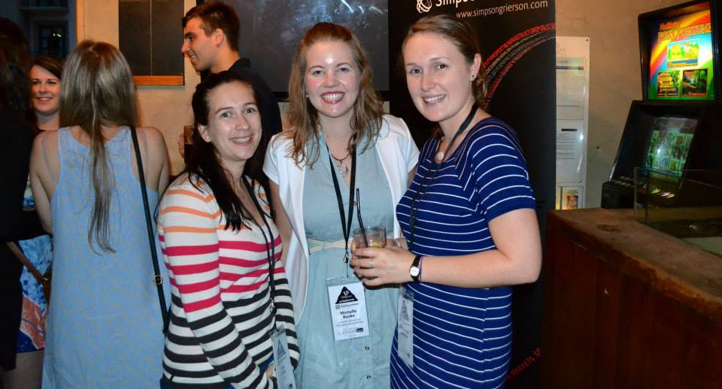
On April 1st 2014, a multitude of young planners descended on Queenstown for the annual Young Planners (YP) Congress. This was my fourth YP Congress, and like previous years, the networking opportunities, inspirational speakers, and advice gained from other planners, made this conference invaluable. A huge thank you to Richard Kemp and the organising committee of Alana Standish, Katrina Ellis, Sarah Picard and Loek Driesen who went over and above to organise the event. Due to the committees efforts, the congress ran smoothly, was well advertised and full of incredible prizes. Anyone fancy a free jet boat ride just because they asked a speaker an interesting question?
Perri Duffy (the national YP representative), and Lincoln University students Michelle Ruske and Kimberley Freeman at the pre-event.
For those of you unfamiliar with the Young Planners Congress, it is a one day event that runs alongside the New Zealand Planning Institute Conference, and is specifically designed to target young planners (those studying or with less than five years work experience).
The congress kicked off the night before with a social event as is tradition. Held at the Buffalo Club, this was mainly an evening of mingling, and all those present were challenged to an ‘Amazing Race’ style competition around the town, scrambling to find bridge construction dates, take photos with certain sculptures and more. This was a great way for everyone to get out of their comfort zone and interact in randomly selected teams.
The official day of the Congress was held at the top of the Queenstown Gondola, in the Skyline Building – a fitting location to discuss planning issues for Queenstown and the surrounding area. The first speaker was Matt Hollyer, General Manager at Shotover Canyon Swing, whose enthusiastic presentation delivery ensured everyone started the day engaged and interested. Hollyer talked about the issues involved in getting planning consent for the Canyon Swing and a proposed flying fox. This included the DOC concession needed to operate in a recreation reserve, the unique challenges facing the operation (no precedents existed), a regulatory environment with a large number of hoops (including amusement device regulations and crisis management plans) and a tough economic market where at least four adventure activities in the last ten years have gone ‘bust’. Hollyer’s advice to Young Planners was to engage in conversation with clients and applicants and explain clearly the reasoning behind the requirement of certain information.
Graeme Todd then took to the stage to offer a change of pace. A resource management lawyer in Queenstown, he has appeared in the Environment Court over 200 times. Todd spoke on litigation around commercial jet boating and focused on the 1991 Kawarau Jet Services Ltd V Pro Jet Adventures Ltd, NZRMA 1 case, which essentially was a lesson on ‘what not to do’.
Following this was Kirsty O’Sullivan, a young planner working for Mitchell Partnerships, who presented on noise and Queenstown Airport. With over 5,500 landings a year, and competing land uses nearby, land use and noise have become contentious issues for the airport. As a result, Queenstown Airport considered how to mitigate their activities and this initiated Plan Change 35, which put in place new noise boundaries. The airport also developed a Noise Mitigation Programme whereby they offer acoustic treatment packages. These packages are for activities that contrast the airport’s interests, and were already established within the new noise zones. For example, they may increase insulation in key areas of a residential house.
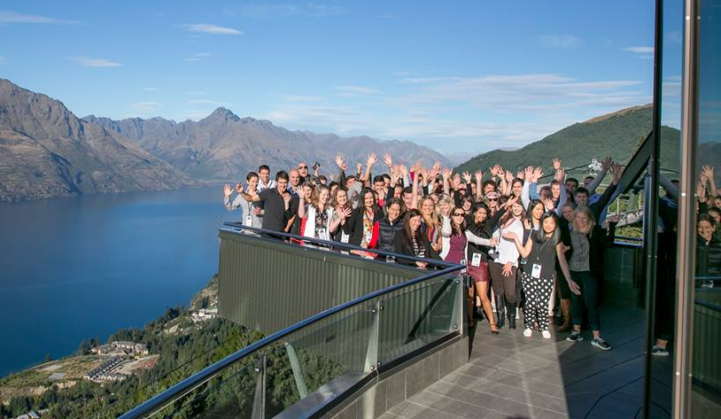
After lunch, Ella Lawton, a Queenstown Lakes District Councillor, referred to herself as a ‘general specialist’ and spoke on a range of issues impacting planning. These included conflicting trends, and the idea that if Queenstown has too many tourists, it will no longer be a place people wish to visit. Lawton also covered the Natural Step and the idea that “localisation is a solution multiplier”. A councillor for only 5 months, she challenged the young planners to think about what it means to build a place where ‘talent’ wish to live.
The key note speaker for the YP Congress 2014 was Brent Toderain of Toderian UrbanWORKS. The former chief planner of Vancouver, Toderian has over 21 years of experience in city planning. An inspirational speaker, he had an array of advice for the young planners. Toderian focused on density, stating he believed that if you design for different demographics in mind, such as catering for families, they will come. Toderian also stressed that the public needs to be communicated with. Planners need to acknowledge that in the past, density has been addressed poorly, however when addressed successfully it can provide reduced energy use, affordable housing and allows for active transport.
In regards to transport planning, Toderian stressed that he does not believe in balancing transport modes, instead prioritising them. The car should not be banned, just simply prioritised last (after walking, then cycling, then transit). Toderian also emphasised that the best transportation plan is quite simply a great land use plan, as land use generates transport. In regards to walking, Toderian outlined that wall design need to be interesting, not blank, to create attractive spaces. When commenting on an Auckland contract, he expressed that until Auckland becomes the most walk-able city, it will not be the most liveable city in the world. In regards, to cycling he stressed that the key is separation from vehicles.
Toderian finished off with some career advice. He outlined that contrary to urban myth, it is not who you know that makes your career a success, instead it’s who you impress. Toderian told young planners not to be stressed out by the pressure to specialise stating that he is a ‘quintessential generalist’ and that planning is the only profession where you have to think about the interactions of multiple elements. He emphasised integrity and reminded us that credibility takes a lifetime to build.
A lunchtime photo of the 2014 YP Congress delegates taken at the top of the gondola in Queenstown.
Toderian left the audience challenged to think about the idea that gentrification is the single toughest issue for planners around the world and stated we should be thinking about ‘revitalisation without displacement’.
Following this David Kennedy from Ngai Tahu Tourism outlined the history of Queenstown and Shotover Jet. Kennedy stressed that the key to success in tourism is to create a place with variety – “no one attraction can please everyone”.
Peter Willsman, co-chair of the Wakitipu Wilding Conifer Control Group finished the day with a look out the windows of the Skyline building to see the extent of the conifer problem in Queenstown. Willsman talked about how wilding conifer spreads and the methods being used to help control them.
Overall, YP Congress 2014 was an interesting and thought-provoking conference with well-selected speakers covering a range of topics. Watch out for YP Congress 2015 in Auckland!

